St. Louis Public School
205 2nd Street P.O. Box 70,
St. Louis, SK S0J 2C0

Principal: Greg Walker Phone: 306-422-8511
Vice-Principal: Dianne Stigen Fax: 306-422-8299
Secretary: Kelsey Ogden

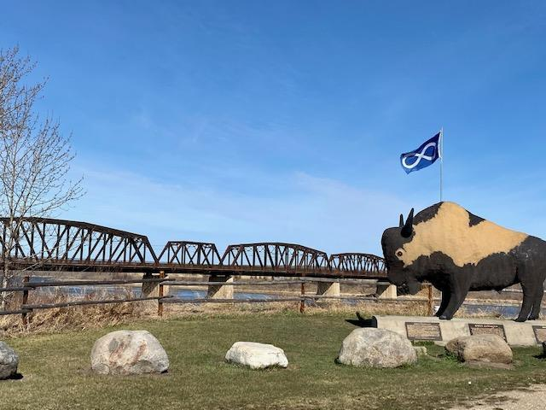

Bridge to Success

REGISTRATION
- All students must complete a registration form. Forms are available at the office and through our St. Louis Public School Website at https://st.srsd119.ca/
  - For new students to the school, we ask that the parents/guardians accompany the student to register.
  - If you require bus service, please register through our school website or go to srsd119.ca and click on transportation request.

SUPERVISION HOURS

8:35 a.m. – 8:50 a.m.
During all breaks and noon hours
3:20 p.m. – dismissal time

St. Louis Public School Staff

Principal Mr. Walker
Vice-Principal Mrs. Stigen
Secretary Mrs. Ogden

PreK/Kindergarten Ms. Lamb & Mrs. Braaten-Ernst
Grade 1/2 Ms. Aitken
Grade 3/4 Ms. Sarrazin
Grade 5 Mr. Boutin
Grade 6/7 Mr. Wilkinson
Grade 8/9 Ms. Schultz
Grade 10 Ms. Burka
Grade 11/12 Mrs. Olexsyn

FTV Facilitator & Michif Ms. Rancourt
Language Coordinator
Instructional Coach Mrs. Stigen
Inclusive Educational Mrs. Braaten-Ernst
Support
EAs Mrs. S. Boyer
Mrs. Halcro
Mrs. Tait-Sjogren
Mrs. L. Boyer

Library Mrs. L. Boyer
Nutrition Manager Mrs. D. Parent
Social Worker Mr. Horachek
Mentor Mr. Jesse Bush
Caretakers Mr. Bear & Mrs. McDougall

Bus Drivers Mrs. B. Parent
Mr. Lussier
Mrs. D. Parent

Caretakers Mr. L. Bear
Mrs. R. McDougall

BELL SCHEDULE

8:45 Warning Bell
8:50-9:42 Period 1
2 minute transition (High School)
9:44-10:36 Period 2
10:36-10:51 Recess
10:51-11:44 Period 3
11:44-12:04 Lunch-Meal (High School)
Lunch-Recess (Elementary)
12:04-12:29 Lunch-Meal (Elementary)
Lunch-Recess (High School)
12:26 Warning Bell
12:29-1:20 Period 4
2 minute transition (High School)
1:22-2:13 Period 5
2:13-2:28 Recess
2:28-3:20 Period 6
3:20 Student Dismissal

ARRIVAL TIME AND ENTRANCES
- Students must be in their classroom before 8:50 a.m. and before the 12:29 p.m. bell. Please be respectful of social distancing while entering and exiting the building.
- Grade 6 to 12 students use the northwest entrance. Ms. Lamb’s PreK/K class and Ms. Aitken’s Grade 1/2 class use the southeast entrance. Ms. Sarrazin’s Grade 3/4 class and Mr. Boutin’s 5 class use the northeast entrance.

EDSBY
- Edsby is a learning management system that allows easy communication between the school and our community. Parents are able to receive announcements, view student progress, communicate with teachers, and report absences using a computer or cell phone. Edsby can be accessed at srsd119.edsby.com.
- Please check Edsby regularly as this will be the primary way that student progress will be reported.

FACEBOOK
- SLPS is on Facebook. Be sure to follow us for news about future events and postings about the exciting things happening each day. Follow us @slpseagles

BUS REMIND
- To receive updates about SLPS busses download the Remind app and enter the code “stlbus” or text (902)701-9279 with the words “join stlbus”.

SIGN OUT and SIGN IN
- All students must sign out when leaving the school grounds during the school day. The sign out sheet is located at the school office. A student must sign in upon returning to the school.
- Students are not permitted to leave the school grounds during the breaks.

VISITORS
- Guests are welcome. St. Louis Public School is a secure building. During school hours, all outside doors are locked. To gain access to the facility be sure to ring the buzzer beside the main doors. Please do not ask staff members to open the locked doors during the school day. ALWAYS use the main office doors to enter during school hours.

CONTACTING STUDENTS DURING CLASS HOURS

- Please call the office and if the student needs to return the phone call, he/she will do so during one of the breaks or noon hour.
- Please do not text or call your child during class hours. There is not any acceptable use of a cell phone during class hours, unless directed by a teacher in an educational fashion.

ATTENDANCE
- Students must attend school regularly and punctually to be successful. Parents/Guardians please notify the school (Edsby, phone, email) before 8:45 a.m. if your child is going to be absent or late.
- Students are considered absent if there is no phone call from parents/guardians.
- Appointments for students should be made outside of school hours.
- Parents can check student attendance at any time using the Edsby platform.

SCHOOL FEES
- Please pay student fees as children register using the schools online cash service available at www.srsd119.ca/school-cash-online.
- All student fees are required to be paid in full (including fees from past years that have not been paid) for students to participate in Graduation cap and gown ceremony.
- Pre-Kindergarten – no fees.
- Kindergarten: $15.00 to pay for crayons, pencils (school supplies) and tissue.
- Gr. 1 to 7: $30.00 to pay for holiday crafts such as Christmas, Easter, Valentine’s Day, Mother’s & Father’s Day and for field trips during the year. Please note that if there is more than one field trip a note will be sent home with the amount owing.
- Gr. 8 – 12: $30.00 to pay for tissue, special projects and curricular trips.

- P.A.A. Fees
- Gr. 7: $20.00 to pay for shop consumables such as nails, screws, glue, sandpaper, paint, stain, varnish, and wood for projects.
- Gr. 8-10: $25.00 to pay for shop consumables such as nails, screws, glue, sandpaper, paint, stain, varnish, and wood for projects.
- Gr. 11 & 12: $25.00 to pay for the same items as above plus an extra amount will be charged that will correspond to the student’s choice of project.

Graduation Fees (graduates only): $50.00 to pay for creation and the basic tassel, cap and gown rental. (extra tassels are to be paid for at the time of ordering)

LUNCH
- All town students are encouraged to go home for lunch. Parents who need their children to eat at school are asked to communicate with the office in advance. Bus students will eat their lunch as follows:
Gr. PK – 7 - in their respective classrooms
Gr. 8-12 - Outside the kitchen or in an available room.

LUNCH PROGRAM
- S.L.P.S. offers a lunch program. Please see the current school newsletter, Edsby, or Facebook for current lunch menu items and prices. Lunch orders are taken immediately during the first class of the day and we request that any orders phoned in by parents are received by 9:15 a.m.
- Meal Cards are available for $10, $20, etc. each. A small meal is $3.00 and large meal is $4.00. Milk and juice can also be preordered with lunch for $1.00. Meals are to be paid for in advance (or when ordered). Elementary students receive notices to take home so their parents will know when they are running out of money on their meal cards. High school students are told by their homeroom teacher.
- Dishes and utensils need to be placed in the scrub bucket after use.

There are no microwaves for student use.

SNACK
- Pre-Kindergarten to grade 5 students have snack in their classroom.
- Grade 6-12 students will have snack during morning break.

GYM REGULATIONS
  - Food and bottled drinks are only allowed in the gym during designated times.
  - All students should have school shoes with non-marking soles that are worn ONLY IN THE SCHOOL.
  - A pair of running shoes must be worn when participating in all activities in the gym. This applies to grades PK-12.
  - No one is allowed in the gymnasium when there is not a supervisor present.
  - During practices, everyone must remain in the gym area except for the participants who have permission from the supervising teacher/coach to leave.

LIBRARY REGULATIONS
  - Students will have a two-week borrowing time for library materials.
  - Students will be charged the cost of lost library materials.
  - No food or drink is allowed in the library.

MEDICATION
- Students will not be given ANY medication without signed prescribed medication forms.

SCHOOL DISCIPLINE
- Students are responsible for their actions and their words.
- Respect yourself and others. Respect others property.
- Good communication between the school and our students’ home is a core belief at S.L.P.S.
- Each student is unique and each will be dealt with in a manner that is fair to each situation.
- It is your responsibility to learn and not interfere with other’s right to learn.
- The safety of everyone at S.L.P.S. is a shared responsibility. Students are expected to behave in an orderly and respectful manner while in the school, and to treat the facility with care and respect.
- SRPSD busses are considered school property and the expectations for behavior apply when students are being transported. All transportation department guidelines need to be respected.

DRESS CODE

- Clothing with inappropriate messages or double meanings should not be worn.
- Students may be asked to go home and/or change if they are not suitably dressed.
- Dirty footwear must be removed when entering the school. Students are required to wear indoor, non-marking shoes while indoors.
- Outdoor clothing is to be kept in students’ lockers and not worn in the classroom.
- Hoods on bunny hugs and sunglasses are not to be worn in the school.

STUDENT ACCOUNTABILITY:
- Every student shall be accountable to the teacher for his/her conduct on the school premises during school hours and during such hours as the teacher is in charge of a student as a member of a class or as an individual while engaged in authorized school activities conducted in out-of-school hours.
- Every student shall be accountable to the principal for his/her general deportment at any time that he/she is under the supervision of the school and members of the teaching staff, including the time traveling between school and his/her place of residence.
- Students are subject to the policies of the Board, to the driver of the school bus, and to any other person who is appointed by the Board for the purpose of supervision, during hours when students are in the personal charge of such employees of the Board provided that such employees shall be responsible to and report to the principal according to procedures approved by the Board.
- You have the right to learn and the responsibility to allow others to learn.

CLASSROOMS

Teachers are responsible for the discipline in the classroom.
- Students are expected to:
- Put in their best efforts and work diligently in each class.
- Obey the classroom rules set by each teacher.
- Respect other students and property.

STUDENT TRANSPORTATION IN PRIVATE VEHICLES
- A parent consent form signed by the parents must be obtained for each student to be transported by private motor vehicle.

DRIVER AUTHORIZATION FORM
- We thank you in advance for helping with transportation.
- Drivers must have completed the S.R.P.S.D. “Application for Automobile Driver Authorization” forms to drive students that are not in their guardianship. All drivers transporting students in private vehicles shall provide the principal with a copy of a valid Driver’s License, proof of insurance and a signed application for driver authorization.
- All students riding in vehicles other than their parents’ or guardians’, as organized through the school, must complete the “Student Transportation in Private Vehicles Parental Consent Form.”

INTERNET & TECHNOLOGY
- The internet is an environment of constantly changing, unregulated
information that is used as an information resource. The use of the
internet is a privilege, not a right, and inappropriate use may result in
cancellation of this privilege.

- Misusing internet privileges or damaging St. Louis Public School’s technology will result in a suspension of privileges as well as paying for the damages.

LOCKERS
- All students from Grades 6-12 are assigned lockers. Students are to keep their belongings in their lockers. Lockers may be opened and inspected at the discretion of the principal. In order to prevent theft or damage of student belongings, we encourage all students to use their lockers and keep them locked at all times. The school is not responsible for loss or damage to student belongings.

BIKES
- Please park all bikes in the bike rack while at school.

SMOKING AREA
- High School students may smoke or vape only in the designated smoking area on the west side of the school on the edge of the road off of school property.
- If lates become an issue, this privilege will be revoked.

CELL PHONES
- Pre-Kindergarten to Grade 7 students are not permitted to bring technology to school. Inappropriate use will result in students having their device taken to the office. A parent/guardian will be required to pick up the device if there is use during class hours.
- Cell phones may be used in grade 8 – 12 classes at the discretion of the teacher for an educational purpose.
- Cell phone use is permitted at breaks for grade 8 -12 students but the recording of audio & video, and photographs is prohibited.
- Any recording of school events must comply with the Local Authority Freedom of Information Protection of Privacy guidelines.

VEHICLES
- Students who drive to school must park across the street or behind the bus sign. (Parallel parking only)
- High school students are not to be at their cars during breaks.

STUDENT EVALUATION POLICY:

Every student’s grade book is available through Edsby.
- Early in the school year, teachers establish the criteria they will use for student assessment. Assessments of effort (FASA) is separate from the assessment of academic skills. Students and their parents should be aware of the 4 point criteria that will be followed.

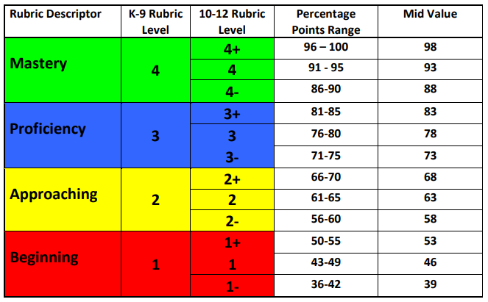

HIGH SCHOOL REGULAR PROGRAM – GRADES 10-12

Students must complete 24 credits at the 10, 20 and 30 level in order to graduate.
- In the event that a student believes that there is a discrepancy in the final mark of a course, students can request that the teacher review the score within 5 school days of the mark being posted. If the student and/or their parent/guardian is not satisfied with result they can contact the principal within 5 school days of receiving the result.
- Students may request an accelerated credit attainment schedule. Any such requests must have the support of the principal and the student’s parent/guardian. If approved a plan will be co-constructed with the student that incorporates strategies that are personalized to the student and their needs.
- Credit enhancement may be requested by a student within 5 school days of final marks being posted. If the classroom teacher and principal approve the enhancement the student, teacher, and parent/guardian will co-construct strategies that are personalized to the student and their needs. This plan will include a closing date, usually within 30 days of the course end date. Credit enhancement is not an option for courses requiring a provincial examination.

DROPPING A CLASS FOR GRADE 11 AND 12 STUDENTS
- If a student wishes to drop a class, all steps must be completed by the due date.
- Students will sign up for classes in the spring for the following year.
- In the fall, students will receive their timetable and attend all classes regardless of intention to drop.
- Students must meet with the principal to discuss graduation requirements, future plans, other class options, and implications associated with a spare.
- Students must bring back to the office a completed drop form signed by their parent/guardian.

GRADUATION
- Only students who meet the Ministry of Education minimum of twenty-four credit requirements for graduation and paid for all school fees will be allowed to participate in the cap and gown ceremony.

FINAL ASSESSMENTS and RE-ASSESSMENTS
- Year​-​end​ ​re-assessments​ ​will​ ​occur​ ​at​ ​the​ ​10,​ ​20,​ ​and​ ​30​ ​levels​ ​in​ ​the​ ​core​ ​classes​ ​and​ ​at​ ​the teacher’s​ ​discretion​ ​in​ ​elective​ ​classes.​ ​These​ ​are​ ​re-assessments​, ​therefore​ ​previous assessments​ ​need​ ​to​ ​be​ ​completed​ ​to​ ​an​ ​acceptable​ ​level​ ​according​ ​to​ ​the​ ​classroom​ ​teacher.
- To ensure that you are able to reassess and achieve success you must hand in all assignments.
- Not​ ​handing​ in assignments ​​is​ ​not​ ​an​ ​option.
- Final assessments and reassessments are written in January and June of each school year. A schedule will be published on our school’s communication platforms.

St. Louis Public School’s student handbook provides guidelines to ensure our students’ safety during their pursuit of excellence.
- If you have any questions throughout the year please call or visit the school.
- The phone number is 306-422-8511.

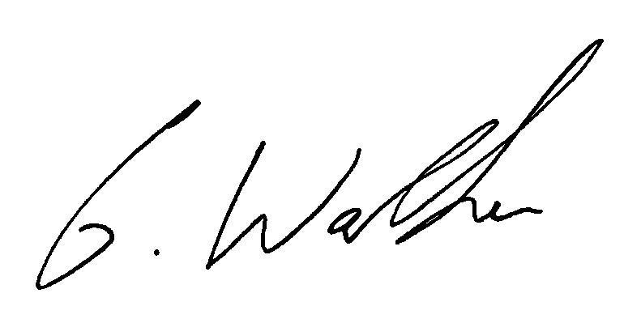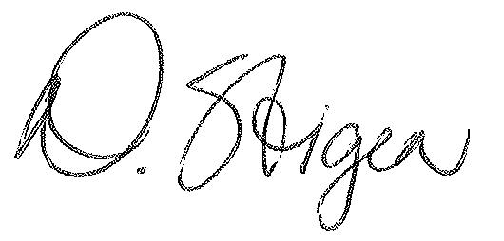
Greg Walker Dianne Stigen
Principal Vice-Principal
gwalker@srsd119.ca dstigen@srsd119.ca

